Product Manual

ASW-724
ALTO PN 106511-724-4A0001

Aircraft Cabin Subwoofer

Alto Aviation
86 Leominster Rd
PO Box 399
Sterling, MA 01564

Phone: 978.466.5992
800.814.0123
Fax: 978.466.5996
E-mail: tech@altoaviation.com

www.altoaviation.com

REVISIONS
REV # | ECN # | Description of Change | Approved | Quality | Date
1 | NDI | Initial Release

Copyright/Proprietary Notice

Alto products are continually improved and all specifications are subject to change without notice. Information and data in this document is confidential and proprietary. Reproduction or disclosure of the information contained in this publication or any portion thereof, by any means, without the express written permission of
Alto Technologies Corporation is prohibited.

Copyright © Alto Technologies Corporation. All rights reserved

Service Bulletin List

Service  Bulletin  Number | Subject | Manual  Revision  Number | Manual  Revision  Date

Table of Contents

1.0 General Information 6

1.1 Introduction 6

1.2 Purpose of Equipment 6

1.3 Design Features 6

1.4 Technical Specifications 7

1.5 Outline Drawing 8

2.0 Installation 9

2.1 General 9

2.2 Unpacking and Inspection 9

2.3 Wiring Requirements 10

2.4 Loudspeaker Placement 10

2.5 Connector Pinouts 10

2.6 Mounting Hardware 11

3.0 Instructions for continued airworthiness 11

3.1 Periodic Maintenance 11

4.0 Troubleshooting 11

4.1 Basic Troubleshooting 11

5.0 Environmental Categories 12

List of Illustrations

Figure 1: ASW-724 Image 7
Figure 2: ASW-724 Outline Drawing 8
Figure 3: Connector Pinouts 10
Figure 4: Basic Troubleshooting 11
Figure 5: Environmental Categories 12

- General Information
  - Introduction
This manual contains information for the installation and operation of Model ASW-724, P/N 106511-724-4A0001, Aircraft Cabin Subwoofer.
This document includes product information such as mechanical, acoustic, and electrical characteristics.
  - Purpose of Equipment
The ASW-724 is a lightweight, high power, bass reflex subwoofer module designed for placement where availability of cross-sectional area between the subwoofer mounting location and the cabin is minimal, such as in cabinets, under divans, or beds. The enclosure combines direct radiating woofer energy and bass-reflex port energy into a single aperture, allowing for very low-profile coupling to the cabin listening space. The high excursion 5.25” driver is precisely matched to the acoustically tuned enclosure resulting in high output and lower frequency bass roll off. The motor structure of the driver is designed to be lightweight and have low magnetic leakage compared to conventional designs. This subwoofer is an integral part of the ALTO Aviation Entertainment System (AES), a complete audio system in which the amplifiers and speakers are customized and matched to the acoustics of the aircraft to provide the finest audio available.
  - Design Features
The ASW-524 is designed to be inherently protected by internal mounting. It is 4.1 inches deep with an aperture profile of 1” x 8”. It has an aluminum enclosure with welded seams. The speaker has a maximum power rating of 50 Watt RMS (30Hz – 200Hz).
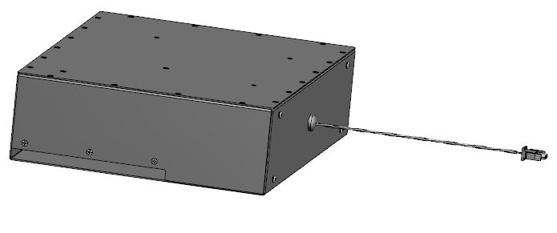

Figure 1: ASW-724 Image

  - Technical Specifications
Product Code 106511-724-4AXXXX
(4 Ohm) (Standard connector type A)
Drivers 5.25” high excursion, low magnetic leakage,
high force design
Frequency Response: 30Hz - 200Hz
Impedance 4 Ohm
Continuous Power Rating 25 Watt RMS
Max. Power Rating 50 Watt RMS
Sensitivity 88 dBSPL @ 1W/1m
DO-160F Env. Cat. [A2X]CAB[(SC)(HR)]XXXXXXBXXXXXX[XXXXX]XXXX

Connector
Mating connector 2 pin Amp Universal MATE-N-LOK

Physical Specifications
Weight 5.6 lbs / (2.54 kg )
Dimensions 16.0”W X 12.0”H X 4.1”D (406.4mm W X 304.8mm H X 104.1mm D)
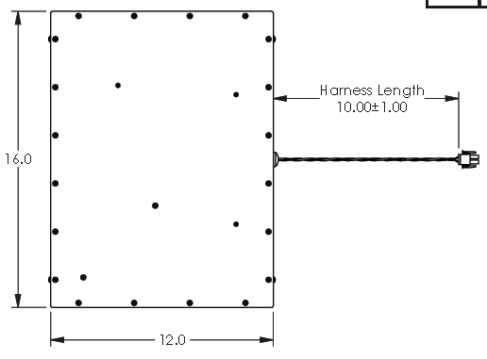
  - Outline Drawing

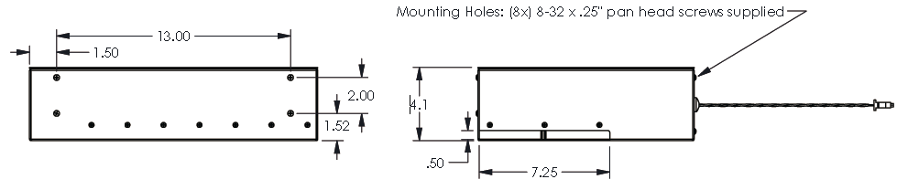

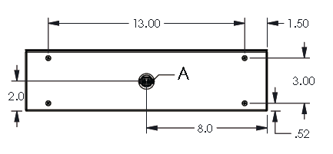

Note: Dimensions are for reference only. See DA (Delivered Assembly) drawing for exact dimensions.
Figure 2: ASW-724 Outline Drawing
- Installation
  - General
The information in this section assists the installer of the unit. Conformity to the electrical wiring and mechanical mounting guidelines will help to ensure proper operation of the unit.
Review all information in this section before proceeding with the installation of the unit.
For assistance during installation please contact Alto using the following contact information:

Alto Aviation
86 Leominster Rd
PO Box 399
Sterling, MA 01564

Phone: 978.466.5992
800.814.0123
Fax: 978.466.5996
E-mail: tech@altoaviation.com
www.altoaviation.com

When connecting this unit to another manufacturer’s product, consult the manufacturer’s specifications and installation instructions pertaining to their equipment.
The conditions and tests for TSO approval of this article are minimum performance standards. Those installing this article, on or in a specific type or class of aircraft, must determine that the aircraft installation conditions are within the TSO standards. The article may be installed only following 14 CFR part 43 or the applicable airworthiness requirements.
  - Unpacking and Inspection
Carefully open the packaging and remove the product. Visually inspect the unit for evidence of physical damage during shipment. Retain the packing materials and all documentation received with the unit. Verify that all components on the packing list have been received.
If the unit has been damaged during shipment, call Alto at 800.814.0123. A claim must be filed with Alto immediately after unpacking. Alto will assign a RMA Number (Returned Material Authorization) and give instructions for shipment. Please use the original carton and packing materials for shipping back to Alto.

  - Wiring Requirements
Loudspeaker wiring should use twisted pair or twisted shielded pair wire. If twisted shielded pair is used, the shield should be grounded at the amplifier end only.
Speaker wires that are too small will attenuate the signal to the speakers. The maximum harness resistance between the unit and each speaker should be < .25 ohm. Harness resistance can be measured by:
- Disconnect the amplifier and speaker.
- Short the harness pins together at the speaker end.
- Measure resistance across the speaker output pins at the amplifier end of the harness.
Avoid parallel runs or installation of audio signal cables in close proximity of transmitter coax cables, high current DC power wiring, AC power wiring, or other high current wiring.
Avoid installation in close proximity to any device with a strong alternating magnetic field such as an inverter or electrical motor.
Wire size, type, and installation should comply with all industry regulations pertaining to the actual installation.

  - Loudspeaker Placement
Please contact Alto Aviation for additional guidance on speaker placement and alternate solutions.

  - Connector Pinouts
The mating connector is: 2 pin Amp Universal MATE-N-LOK
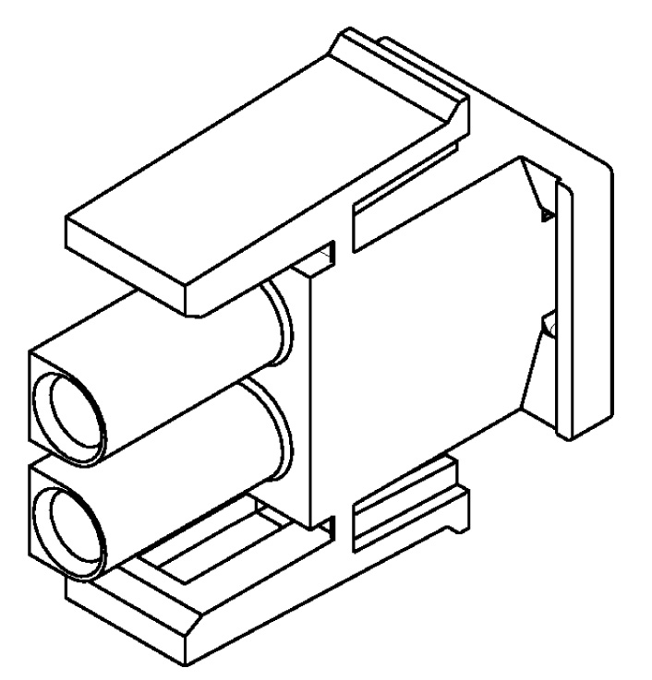
Mating Connector
Amp PN 350778-1

Mating Pin
Pin 2- Amp PN 350550-1

Pin 1+

Figure 3: Connector Pinouts

  - Mounting Hardware
Max intrusion into enclosure = .385”
(8) 10 x .375" screws included with product

- Instructions for continued airworthiness
  - Periodic Maintenance
No periodic scheduled maintenance or calibration is required for continued airworthiness of this product. If the unit fails to perform to specifications, it must be removed and serviced by a qualified service facility.

- Troubleshooting
  - Basic Troubleshooting
Problem | Possible Cause | Possible Solution
No Sound | No output from Audio Amplifier  Wiring / connection problem | Ensure Audio amplifier is providing audio signal to loudspeaker  Ensure continuity between amplifier and loudspeaker on both terminals
Distorted Sound | Audio output from source unit is distorted  Loudspeaker Membrane Damage | Verify that the source unit output has a clean undistorted signal  Inspect the Loudspeaker membrane to insure there is no damage and no debris is lodged in front of the membrane
Poor Audio Quality | Audio source unit controls are improperly adjusted  Speakers are improperly installed | Adjust controls on audio source unit for desired sound  Verify installation of speakers to manufacturer specifications
Noise in Audio System | Vibration in aircraft fixture, grill, or panel | Use Alto Test CD to play sweep tones through the system.  Identify loose panel or hardware that might be rattling and secure.
Figure 4: Basic Troubleshooting

- Environmental Categories

Environmental Tests | RTCA/DO-160G Section | Conducted Test Category
Temperature and Altitude | 4
Low Temperature | 4.5.1 & 4.5.2 | Qualified by similarity to Category A2
High Temperature | 4.5.3 & 4.5.4 | Qualified by similarity to Category A2
In-Flight Loss of Cooling | 4.5.5 | Identified as Category X Not applicable, cooling not required
Altitude | 4.6.1 | Identified as Category X no test performed
Decompression | 4.6.2 | Qualified by similarity to Category A2
Overpressure | 4.6.3 | Identified as Category X , no test performed
Temperature Variation | 5 | Qualified by similarity to Category C
Humidity | 6 | Qualified by similarity to Category A
Operational Shocks & Crash Safety | 7 | Qualified by similarity to Category B
Vibration | 8 | Qualified by similarity to Category S , H, Curve(s) C, R
Explosion Proofness | 9 | Identified as Category X , no test performed
Waterproofness | 10 | Identified as Category X , no test performed
Fluids Susceptibility | 11 | Identified as Category X , no test performed
Sand and Dust | 12 | Identified as Category X , no test performed
Fungus Resistance | 13 | Identified as Category X , no test performed
Salt Spray | 14 | Identified as Category X , no test performed
Magnetic Effects | 15 | Qualified by similarity to Category B
Power Input | 16 | Identified as Category X , no test performed
Voltage Spike | 17 | Identified as Category X , no test performed
Audio Frequency Conducted Susceptibility | 18 | Identified as Category X , no test performed
Induced Signal Susceptibility | 19 | Identified as Category X , no test performed
Radio Frequency Susceptibility | 20 | Identified as Category XX , no test performed
Emission of Radio Frequency Energy | 21 | Identified as Category X , no test performed
Lightning Induced Transient Susceptibility | 22 | Identified as Category XXXXX , no test performed
Lightning Direct Effects | 23 | Identified as Category X , no test performed
Icing | 24 | Identified as Category X , no test performed
Electrostatic Discharge | 25 | Identified as Category X , no test performed
Fire, Flammability | 26 | Identified as Category X, no test performed,  Complies with FAR part 25, Appendix F
Figure 5: Environmental Categories

