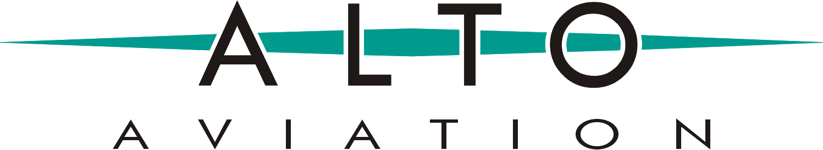

86 Leominster Road, PO Box 399
Sterling, MA 01564 / Toll-Free: 800.814.0123
Media Relations Contact: Cristina Scarlata, Senior Director, Strategic Marketing
cscarlata@altoaviation.com / 561 283 9725 / www.altoaviation.com / @ALTOaviation1

PRESS RELEASE

Sterling, MA, March 7, 2022

ALTO Aviation celebrates its 25th anniversary.

2022 marks the 25th anniversary of ALTO Aviation, serving the Business Aviation industry with premium Cabin Audio Systems and Cabin Management for all private jet types, including rotor, military, and special mission aircraft.

ALTO Aviation was founded in 1997 in Massachusetts by acoustic engineers Don Hamilton and Steve Scarlata to design, manufacture, and distribute premium cabin audio systems for Business Aviation aircraft. Hamilton and Scarlata's prior professional backgrounds included developing high-end car audio systems for Bose®. In 2001, ALTO was commissioned to design the first audio amplifier specifically engineered for Gulfstream OEM aircraft.

Over the years, the company continued developing scalable cabin audio systems customized for most major OEMs; ALTO has developed long-lasting partnerships with all leading MROs expanding into an extensive network of over one hundred and fifty authorized installers worldwide. As a result, the product portfolio has expanded to offer an extensive portfolio of loudspeakers, amplifiers, subwoofers, Public Adress Systems, and Bluetooth® audio.

ALTO's flagship is its signature ALTO nVELOP™ Digital Surround Sound System, which remains the reference of audiophile quality in the industry, acoustically contoured to provide each cabin seat with realistic, rich surround sound. This audio system is expertly engineered and tuned to provide the highest sound performance using the latest digital technology.

All ALTO cabin audio systems get custom on-site audio tuning performed by in-house cabin systems engineers using a proprietary iterative process to accurately provide optimal sound for the VIP and every seat in the cabin. The sound processing is implemented via proprietary DSP inside the ALTO amplifier.
In 2017, ALTO moved the company established new state-of-the-art headquarters in Sterling, Massachusetts. The same year, ALTO developed and launched Cadence Cabin Management System, offering direct replacement passenger controls, System Master Controller, and a cabin control app for Personal Electronic Devices (PED) configurable for all retrofit aircraft.

In recent years, ALTO introduced ALTO Soundstage™, 3D immersive sound specifically designed for the home theater area of the cabin to provide the highest level of sound performance in Business Aviation, using the latest digital technology. As a result, every passenger in the media area enjoys a powerful immersive audio experience that puts the listener at the center of the stage, rivaling the most sophisticated home theater systems.

To commemorate the company's 25th anniversary, ALTO has launched the campaign "The Sound of Business Aviation." As part of the continued commitment to innovation with sustainability and acoustic wellness in mind, ALTO will unveil new audio and cabin management offerings at the upcoming 2022 AEA International Convention and Trade Show in New Orleans, Louisiana, and the 2022 NBAA Business Aviation Convention and Exhibition in Orlando, Florida, and a series of employee engagements, celebrations, and a Social Media campaign #25YearsofALTOAviation to share the company's highlights with all customers, partners, and peers in Business Aviation.

"We celebrate 25 years with deep gratitude to all our clients, industry partners, and every member of the ALTO Aviation team. We have dedicated ourselves to listening to our customers closely and being always there for them. Our mission is to go beyond providing innovative cabin solutions and personalized service; our goal is to hear our favorite compliment: Wow. We celebrate this year with a deep commitment to sustainability and innovation. As a team, we look forward to the next 25 years with optimism, continued commitment to innovation, sustainability, and deep gratitude for the opportunity to continue serving all our clients in Business Aviation." Don Hamilton, President of ALTO Aviation, said.

"As we enter our 25th year serving the Business Aviation community, we look back with gratitude and appreciation to our trusted and long-term partnerships with our customers, industry partners, and peers. We continue growing with new generations of highly-qualified engineers and technologies that adapt to the advancements of our industry. Everyone on the ALTO team continues serving all our clients with the same personalized and professional attention that Don and I pledged 25 years ago." Seve Scarlata, VP of Engineering / R&D, added.

About ALTO Aviation

ALTO Aviation is an aerospace industry leader in designing and manufacturing high-end cabin audio & entertainment systems for all aircraft in Business Aviation with 25 years of experience in Business Aviation.

Our products and solutions include customized premium ALTO MySound™, Inflight Entertainment Systems, Direct Replacement Passenger Controls, Public Address Systems, Bluetooth® audio, Cadence™ Cabin Management System, System Master Controllers, and ALTO Cabin Control App, sold to OEM and retrofit companies in the business aviation industry and installed in corporate/private/VIP jets helicopters, military, and special mission aircraft.

ALTO also manufactures precision sheet metal and machined parts for multiple industries and aerospace. For more information, please visit www.altoaviation.com or please contact Cristina Scarlata at cscarlata@altoaviation.com

For more information, please visit www.altoaviation.com. For personalized assistance, please contact Cristina Scarlata at cscarlata@altoaviation.com

